ANSIBLE TASK 2
Name: Meenakshi
Batch: 7943

Course Assignment
Written two file -:
Inventory.yml - host info
Playbook.yml - install docker on both jenkins and app host
These two files are in drive link

Screenshots of execution of files to install docker on both the nodes
Note: all the setup is done by terraform then logged in bashian instance to run the files and doing ssh to jenkins instance to install jenkins

1- install ansible on bashian instance manually

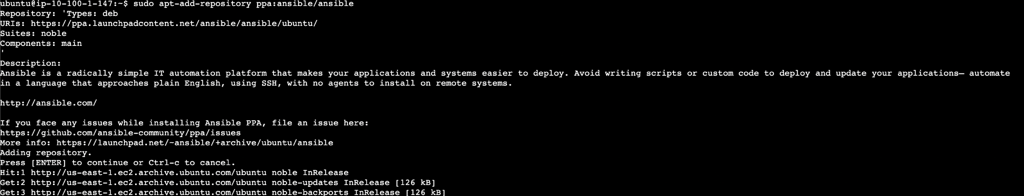



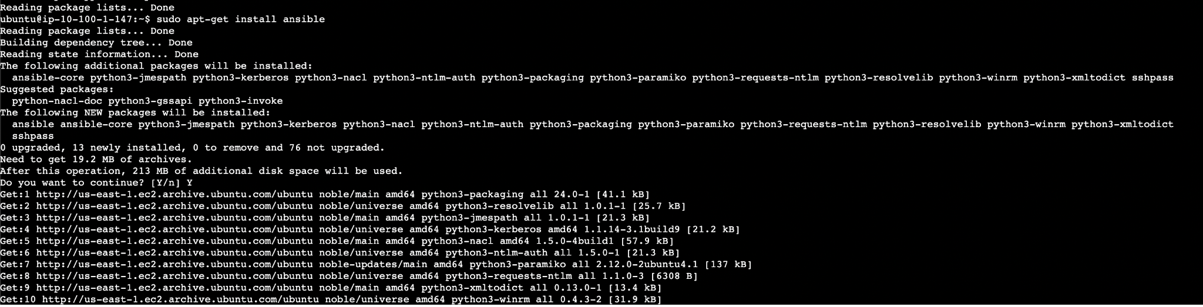

2- write inventory file which is having all the details of instance
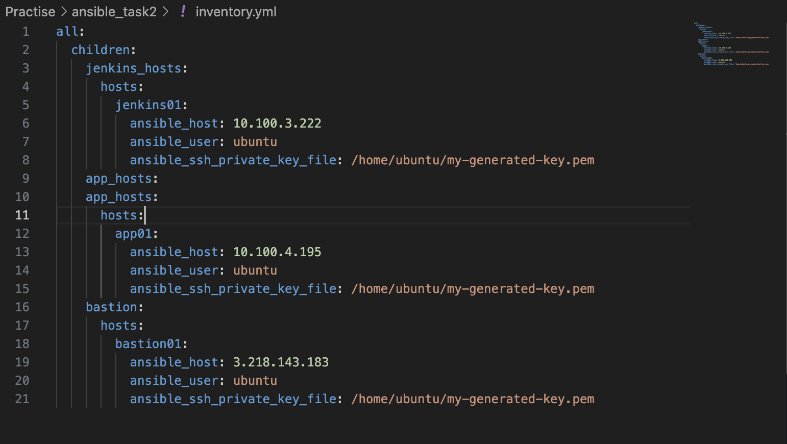
Note: my-generated-key.pem file is created by terraform and attached to the instances
The value key-pair is stored in the local directory while doing terraform apply. From there I have copied the key-pair and stored it in bashian.

3- playbook to install docker on both the instance

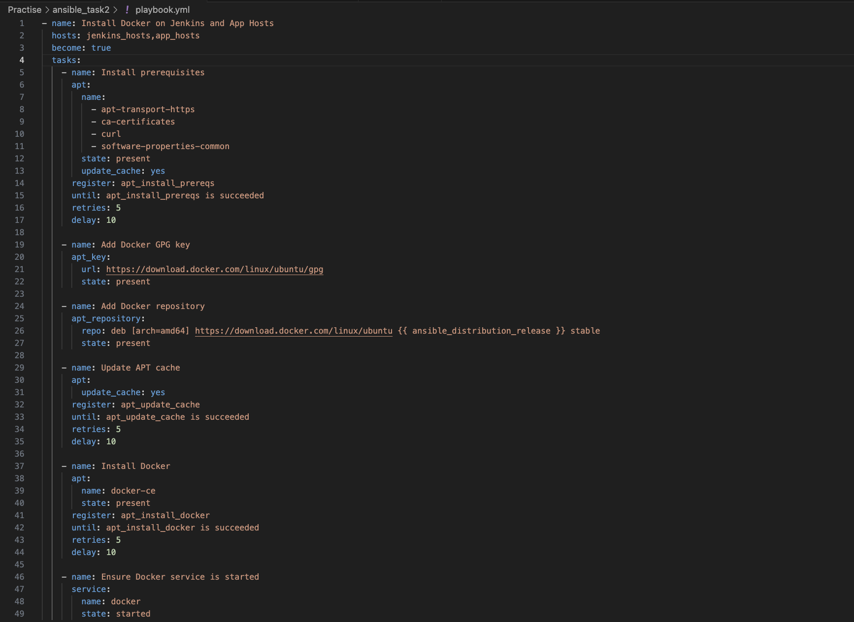

3- checked the connection to instance by using ping command

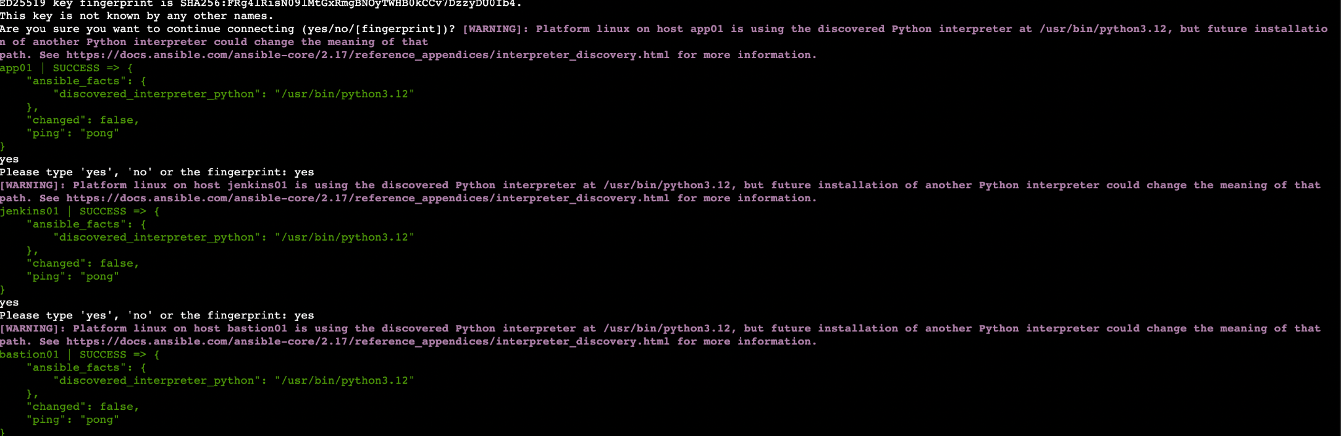

4- ran the ansible playbook to install docker in jenkins and app host

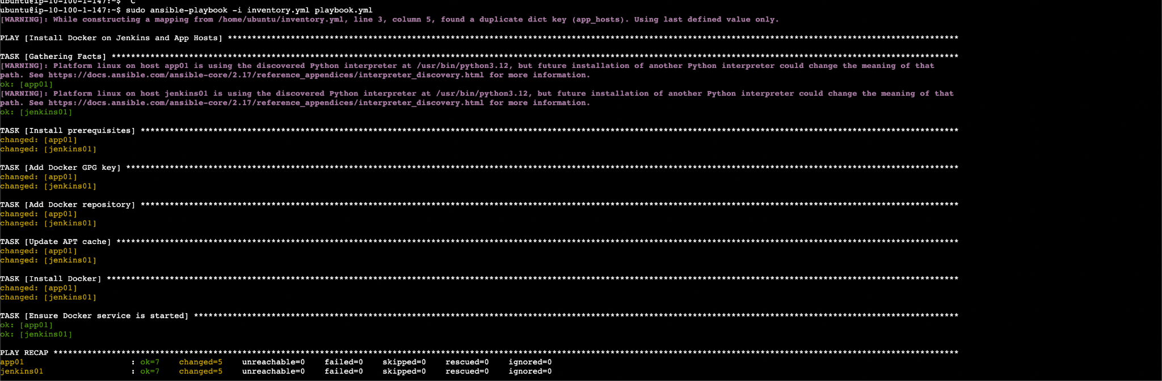

5- To make whether is install or not checked by doing ssh into the instances

Jenkins instance

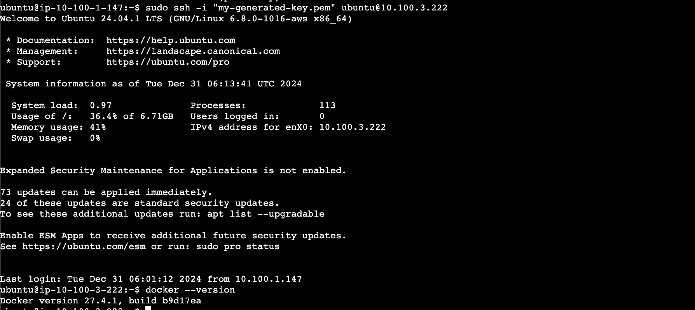

App instance
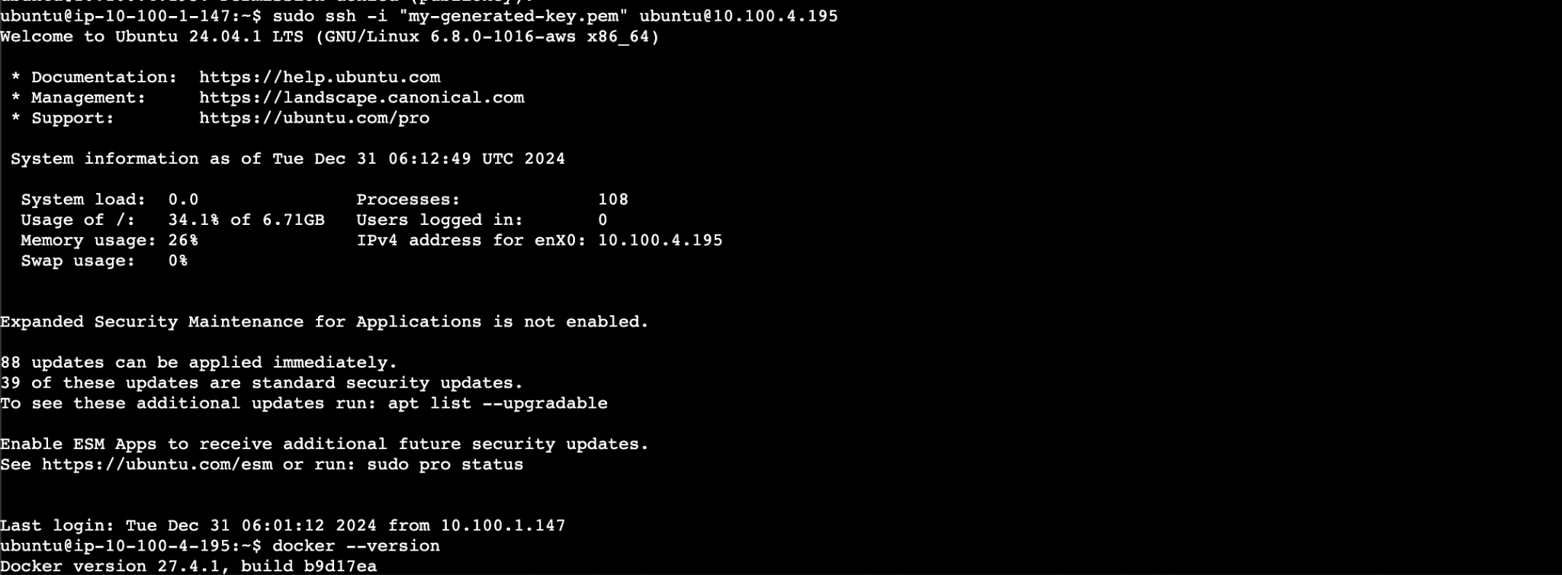

Now manuall installed the jenkins on jenkins instance

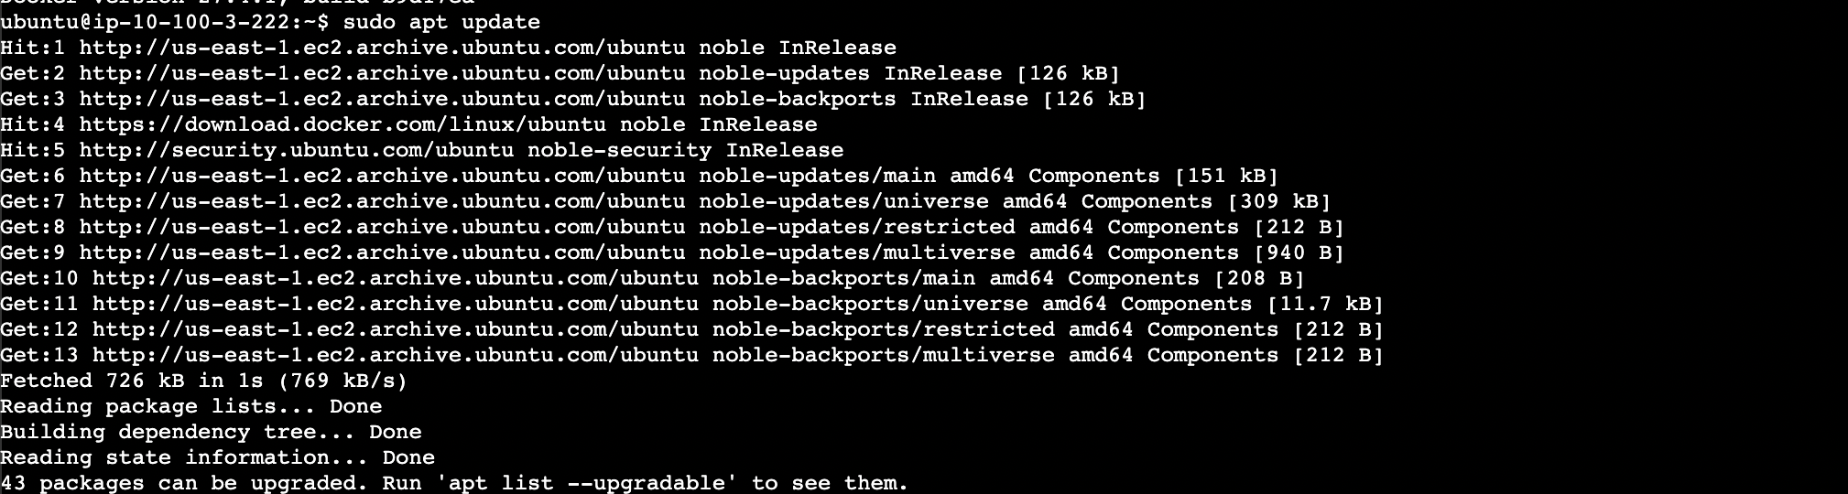

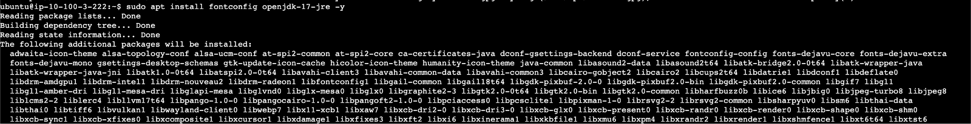

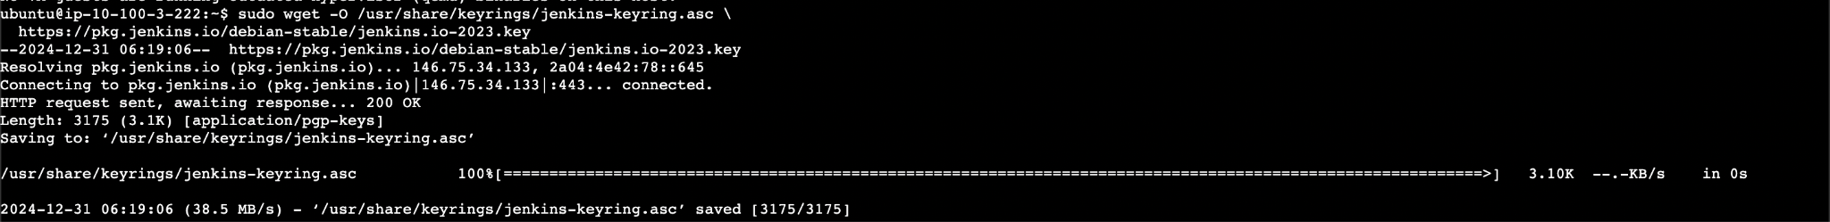

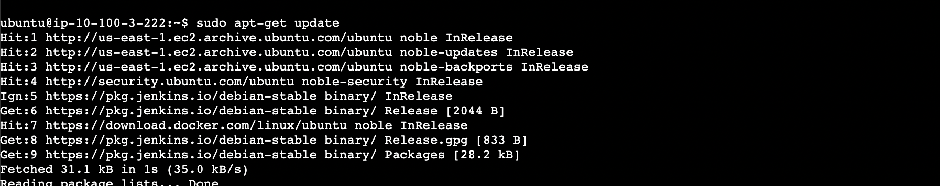

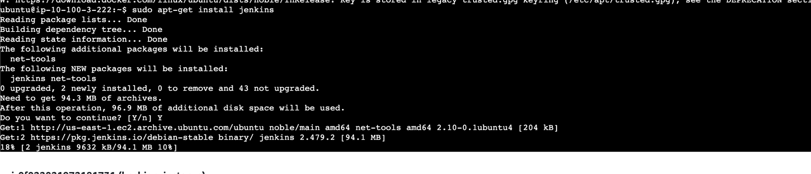

Now will check the load balancer config for launching jenkins via ALB DNS

Open 8080 port on alb sg

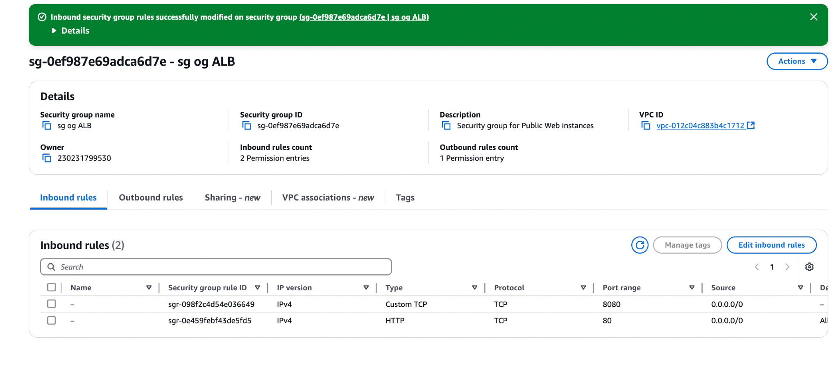

Add listener so that alb can routes request to its registered target
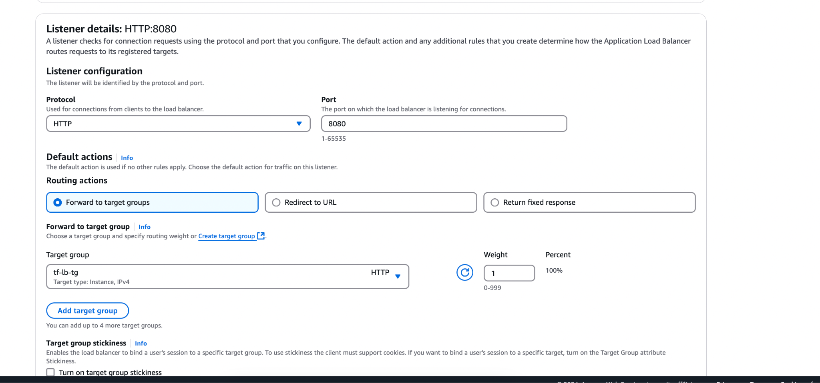

Add the target instance on target group

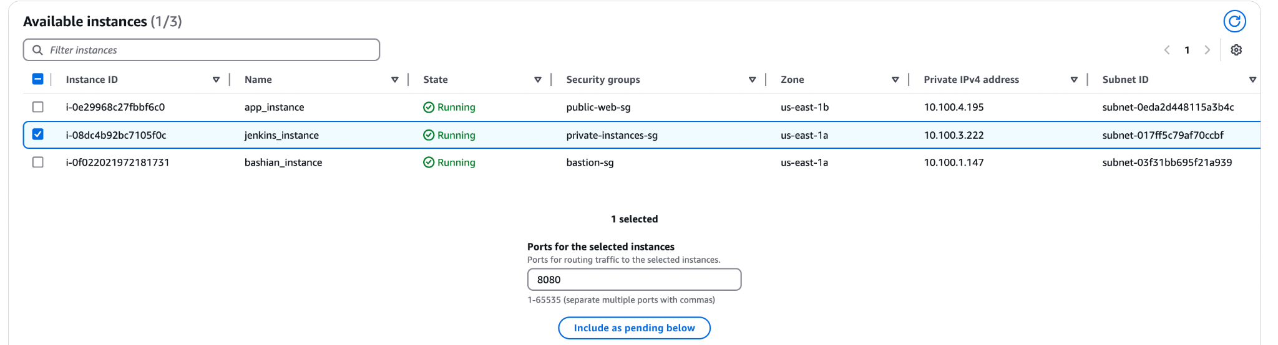

Check all the configuration on ALB
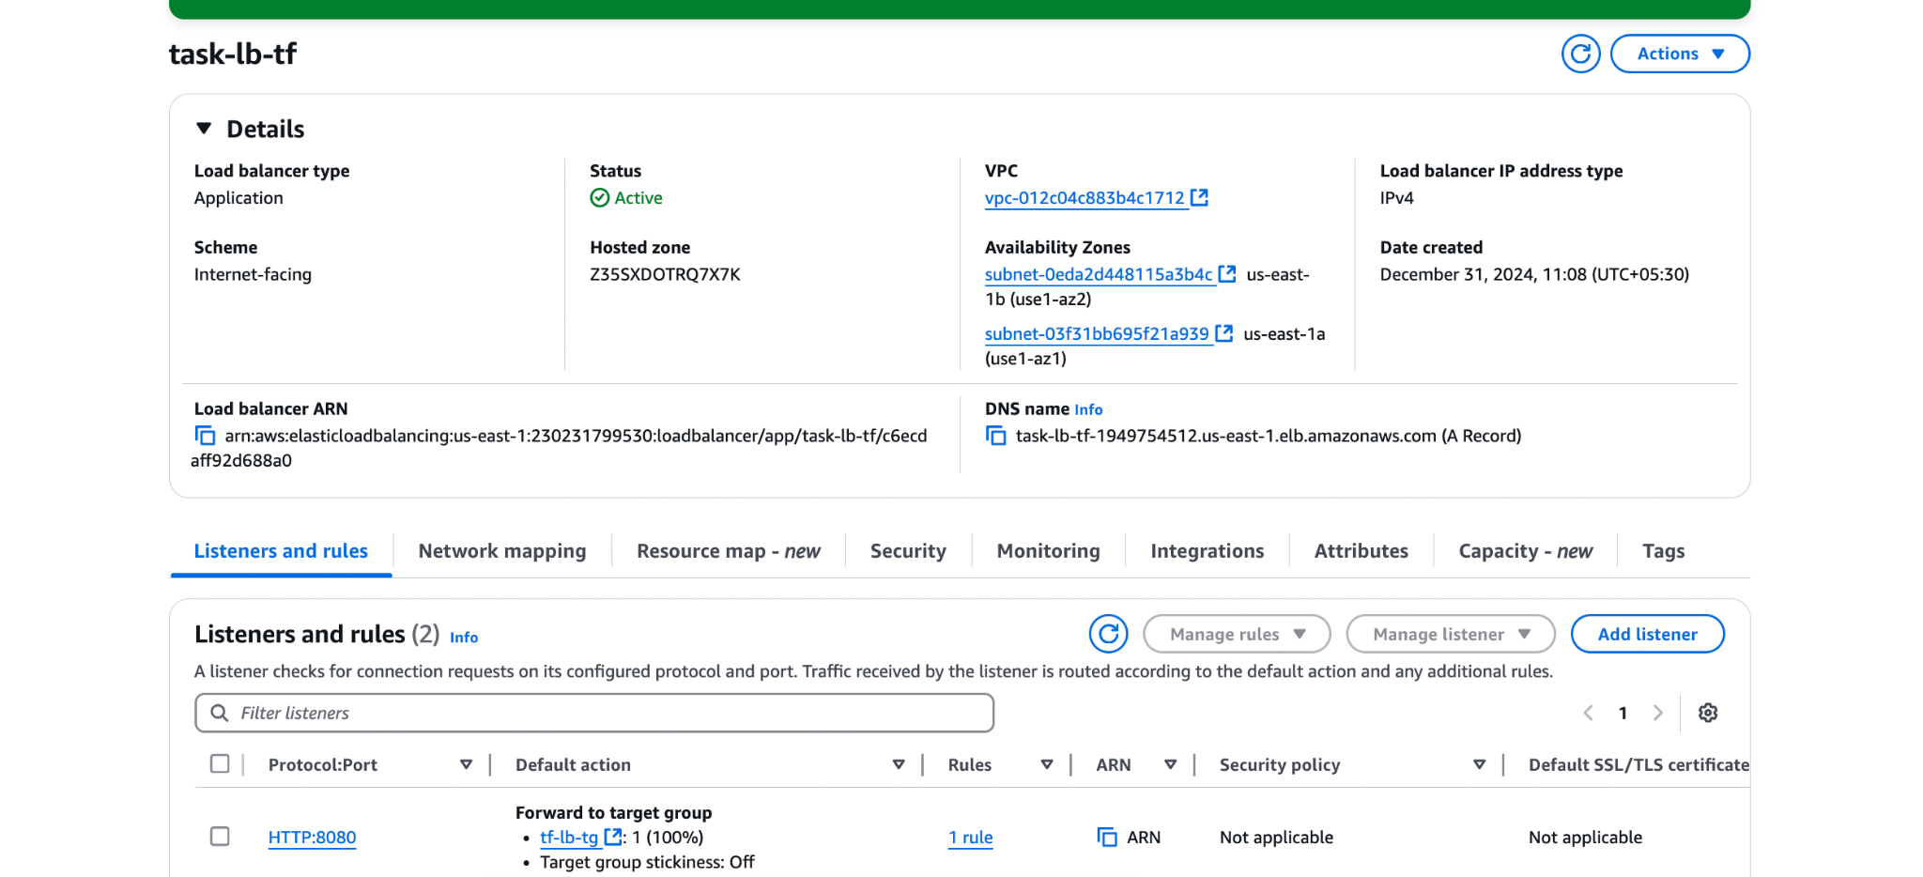

Open 8080 port on sg of jenkins too
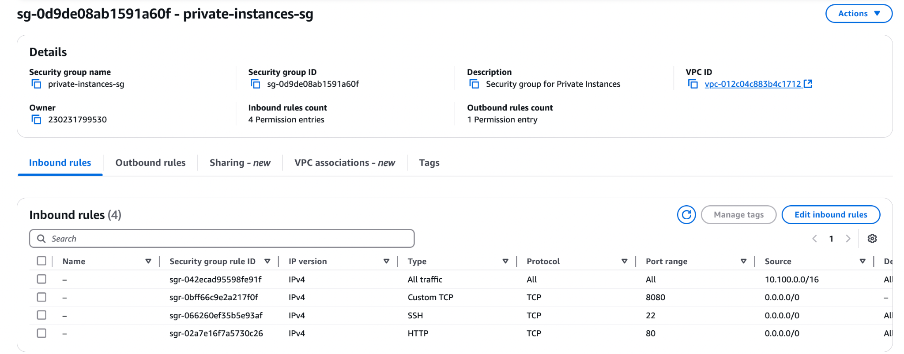

Now hit the DNS of alb we will now see the jenkins app

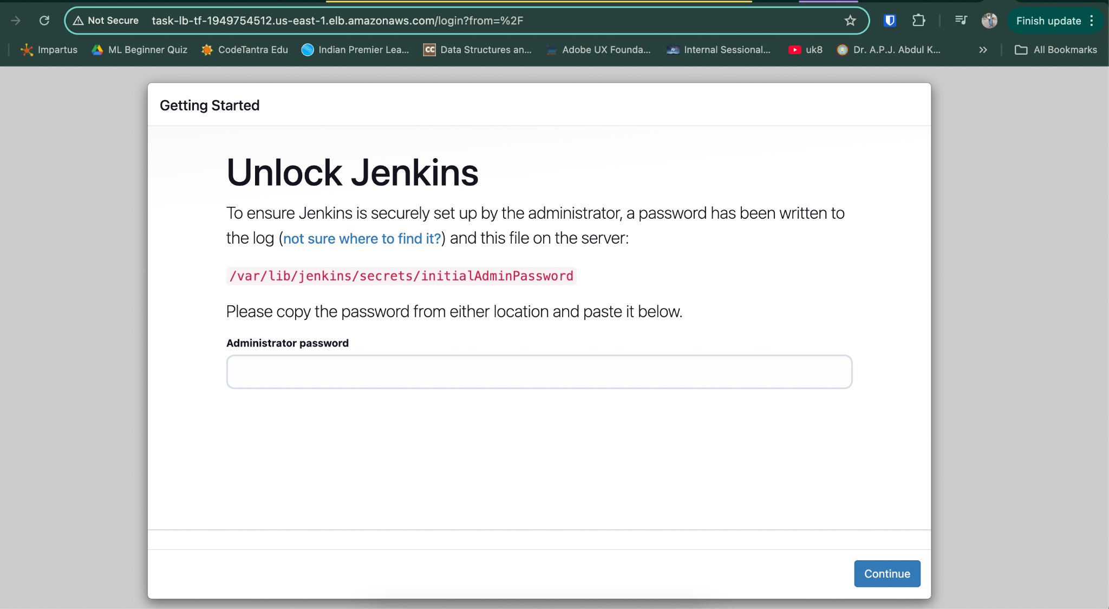

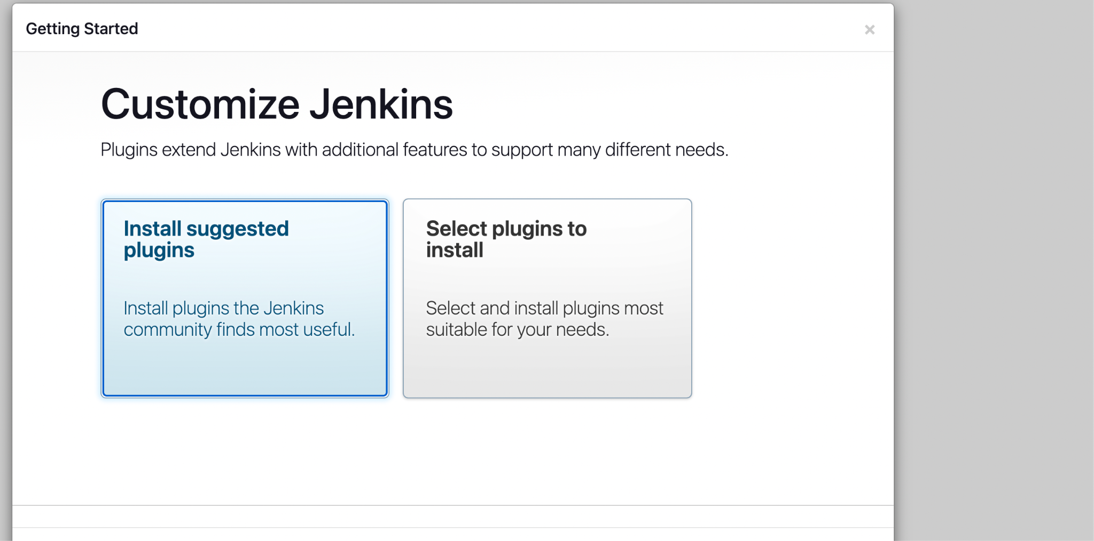

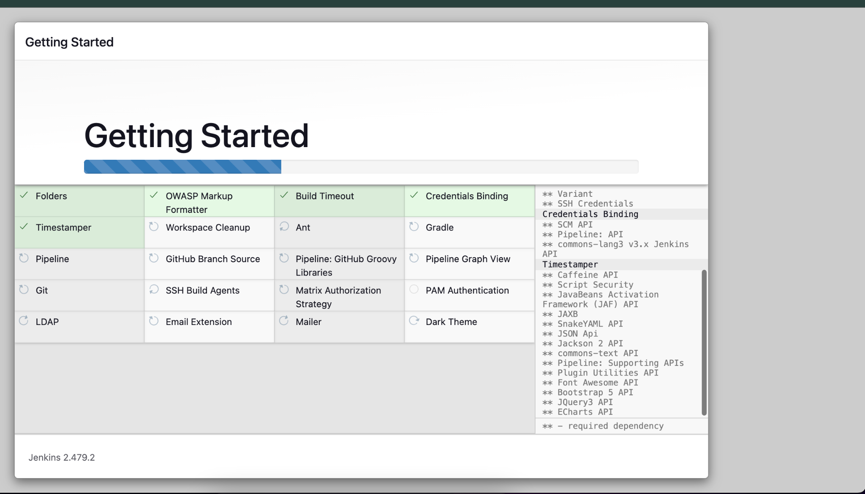

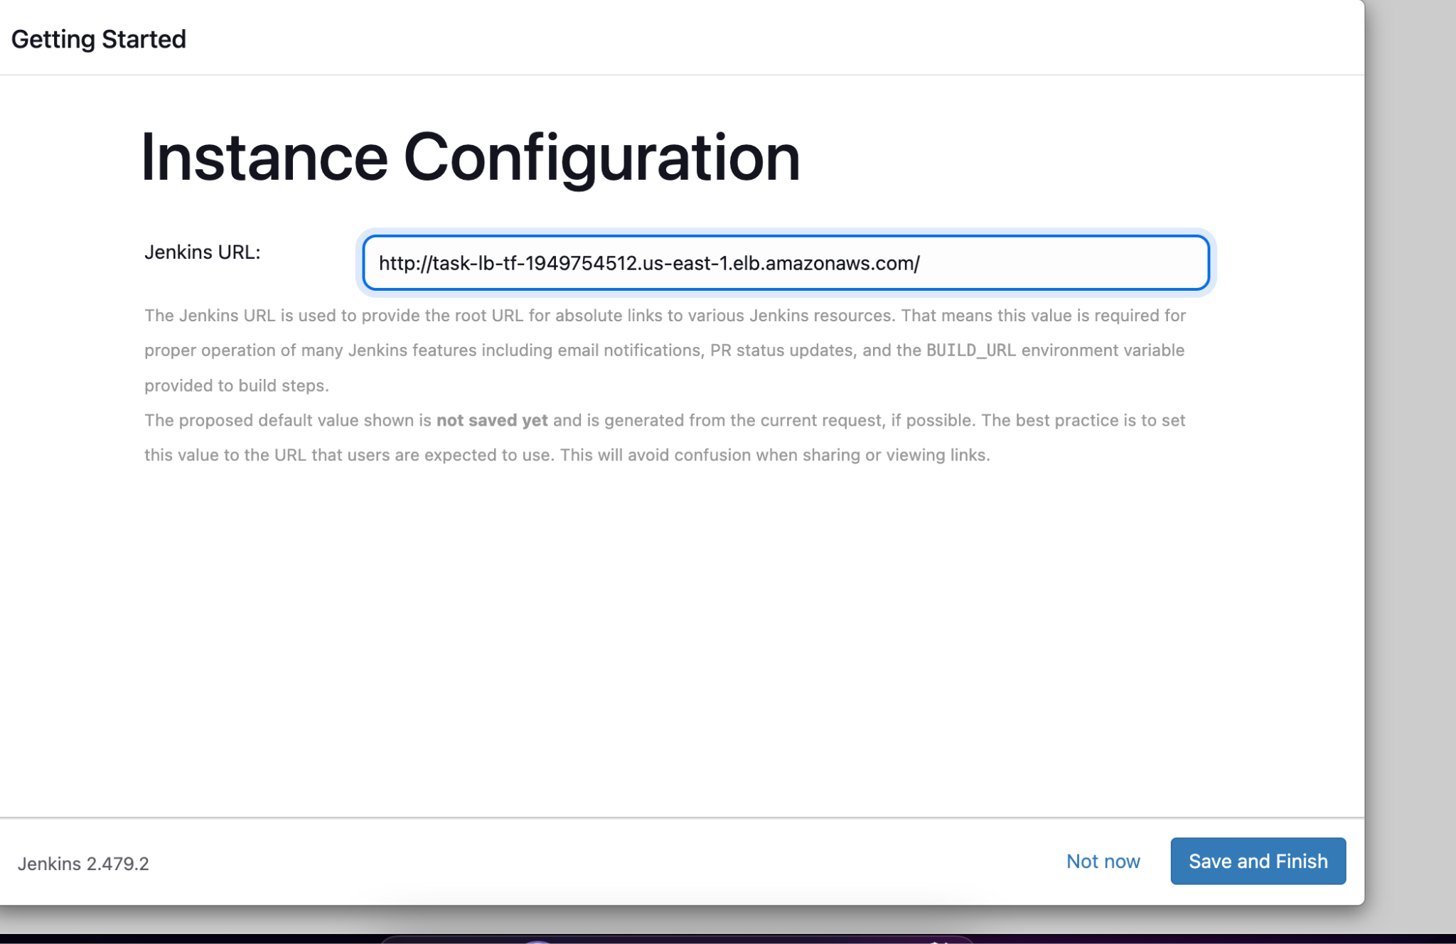

Jenkins is ready to use

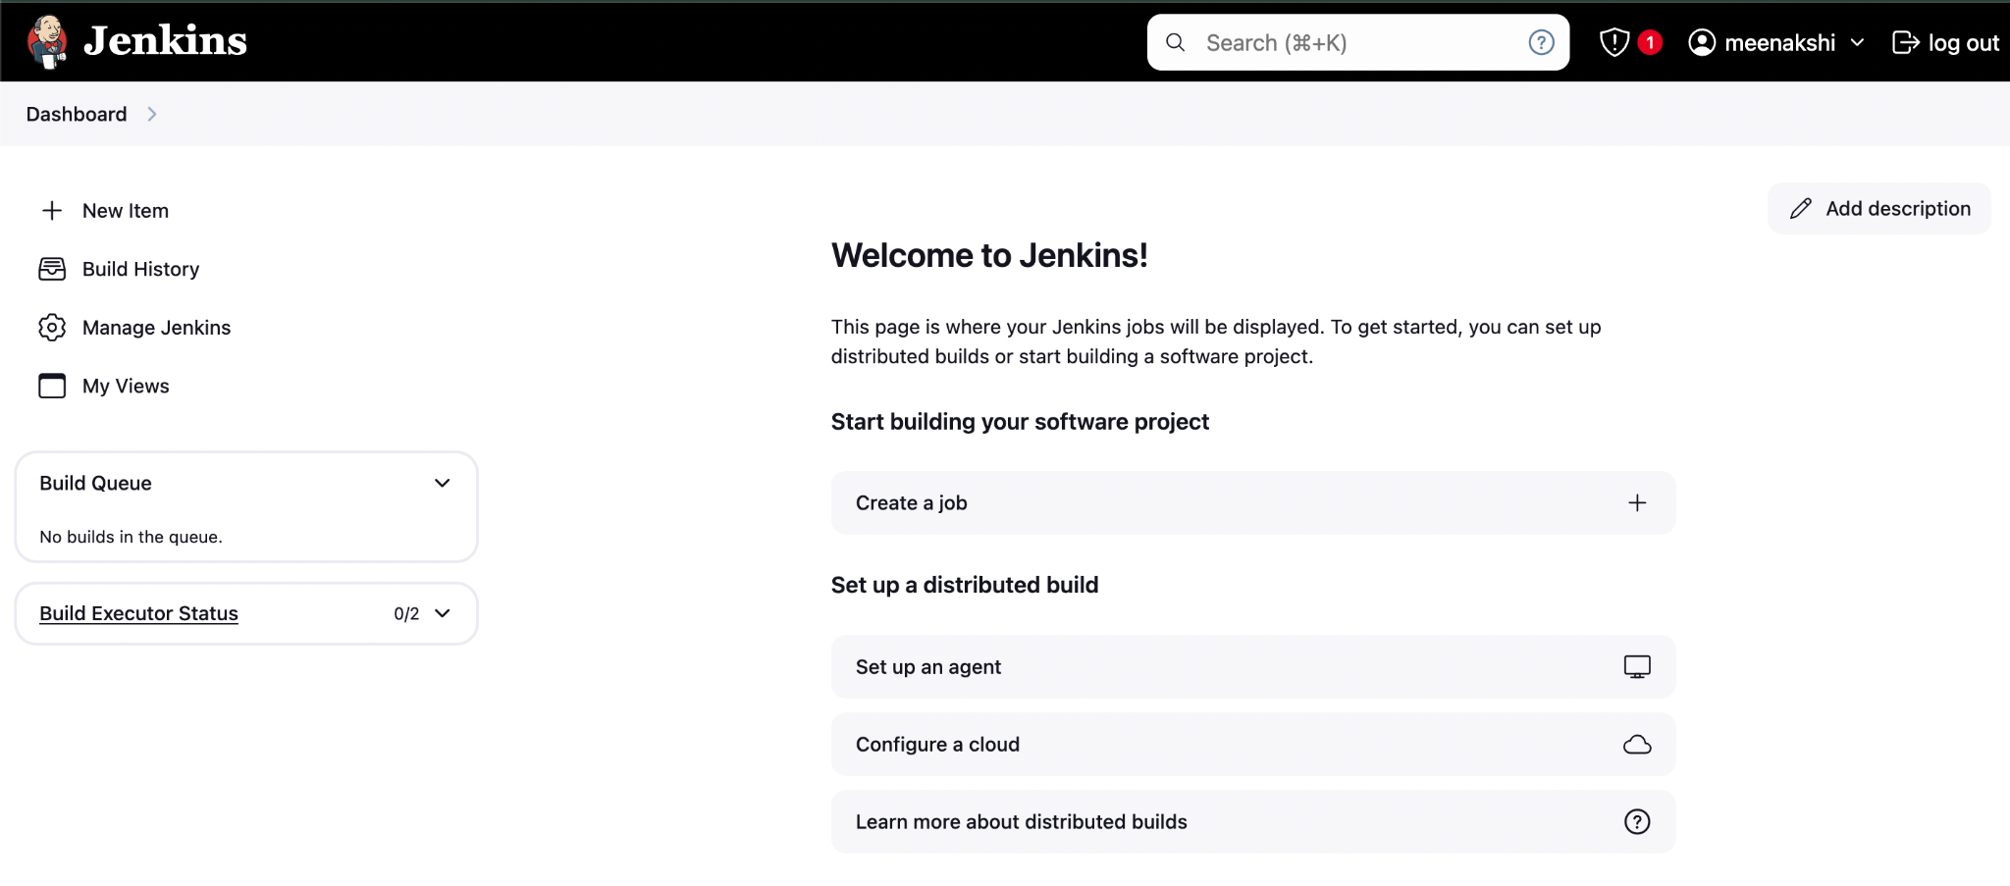
Create ECR

